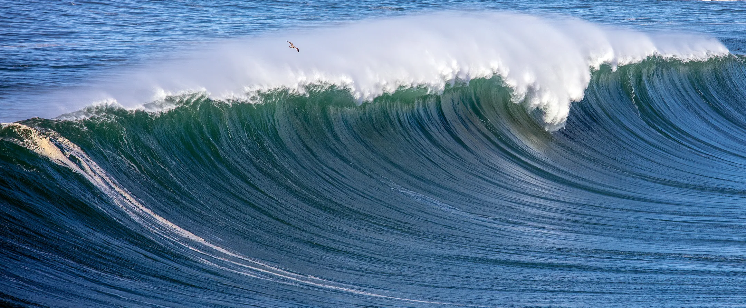
Day 1 Lesson
Notes - What are Waves?
Teacher Intro: Screencast

For today’s lesson, we are getting an introduction to our new unit topic: Waves!

These notes will introduce you to the basics of what a wave is, plus some key vocabulary that we will be using throughout the unit.

These notes will be reviewed on Friday, but you’ll want to review this information before then (HINT HINT).

Directions: Use these Textbook pages to answer the questions below. Consider this assignment part of your important notes to study for this unit.
Hint: the questions are not in exact order, so you will have to jump around. 😎

- Where have you seen waves in your everyday life? | List a few examples:  Ocean waves, sound waves and light waves.
- In Figure 1, the duck doesn’t move to the right, even though the waves are moving. It just goes up and down. | Why?  Because the wave does not carry the duck and the water with it. Waves do not carry the medium with them, they only travel through it. The duck goes up and down, and when the wave is gone, the duck and the water return to where they were.
- So… if waves don’t carry “matter” or atoms/particles, what do waves actually carry? (One word answer - an important word!) | Energy.
- Definition of a wave: | A disturbance that transfers energy from place to place.
- (a) Where does this energy come from?  (b) How does the energy move through a medium? | A mechanical wave is produced when a __source__ of energy causes a medium to __vibrate__.  All mediums are made of tiny __particles__. When energy travels through the medium, the particles __bump into each other__ and pass on the vibration/energy to the ones next to it. This causes a chain reaction of particles bumping into each other, which continues through the medium.
- What is a medium? | Definition: The material through which a wave travels. | Examples: Gases (air), liquids (water), solids (rope).
- There are 2 types of Mechanical waves. | - What are they called?  Transverse waves, longitudinal waves.
- Explain the differences between them:
Transverse waves are waves that move the medium at right angles to the direction the waves travel in. Their highest parts are the crests, and their lowest parts are the troughs. Longitudinal waves move the medium parallel to the direction the waves travel in. Compressions are the parts where the particles are close together. Rarefactions are the parts where the particles are spread out.
(c) Find a picture of each type and insert them here (you can use google images)
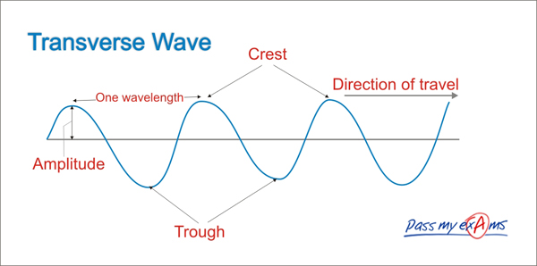
Longitudinal Wave
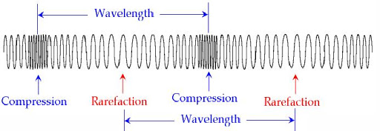
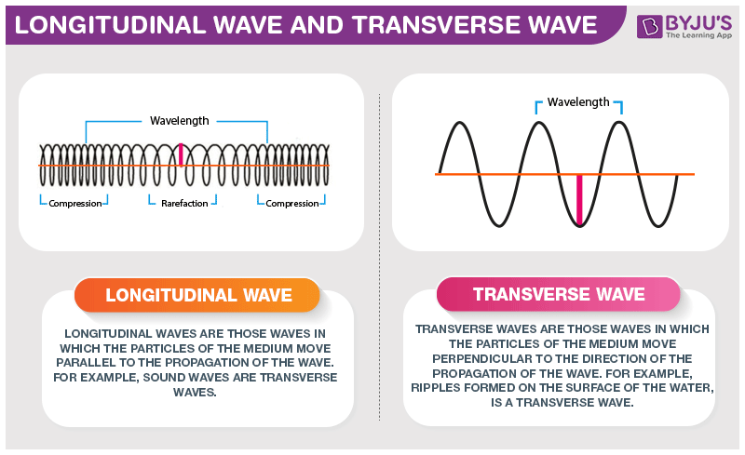

End of notes

