Day 2 Lesson
Light Notes
Instruction Screencast
Complete the notes below using this reading. The questions go in order through the reading and are separated by section. Please answer all questions in complete sentences.

4-1: Ray Model of Light
- Describe how light travels in the ray model?
A shining object emits light rays in every direction in straight lines.

- Use Google Draw (Insert -> Draw) to sketch Figure 4-1 that illustrates the ray model:
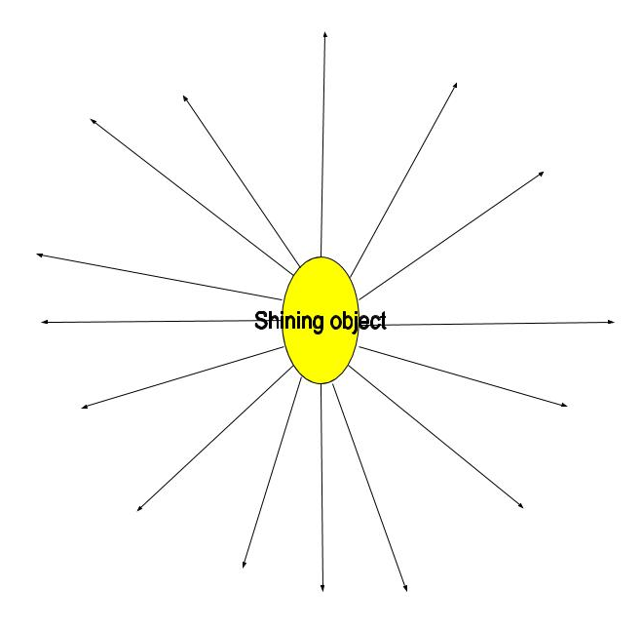

- How does a shadow form?
An object blocks light from another object, thereby casting a shadow on that object.

4-2: Reflection of Light
- Define reflection in terms of light:
When light bounces back.

- Explain the difference between regular reflection and diffuse reflection:
Regular reflection is when light bounces off a very smooth surface such as glass or water. During regular reflection, all light rays hit the surface at the same angle and they are reflected at the same angle. Diffuse reflection is when light bounces off a rough surface such as a rock or a wall. During diffuse reflection, all light rays hit the surface at a different angle and bounce back at a different angle due to the uneven surface.

4-4: Color
- What can happen when light strikes an object?
Light can be transmitted, absorbed, or reflected. When it is transmitted, it goes through the surface. In case of transparent objects the passing light has high detail, in case of translucent objects the passing light has low detail. When light is not transmitted through an object the object is opaque. Eye can sense reflected light. This is how we see obejcts and colors.

- An object that does NOT transmit light is said to be ____opaque___________________. .

- Can light that is totally absorbed reach your eyes?(highlight one) YES / NO

- Explain, in detail, why are objects the color that you see? For example, why would you see a purple cover on a book? Use FIGURE 4-18 to help you answer the question.
Objects are the color that we see them because that is the only color they reflect, they absorb all other colors. A purple book reflects only purple and absorbs all other colors. We see purple because our eyes are only able to see the light that is reflected. If an object is white, that means all colors are reflected back and none is absorbed. This appears to us as white. A black object absorbs all colors and none are reflected back, so we see no color and this appears to us as black.

- When you see a white object ____all____________ the colors are ____reflected________________.

- When you see a black object ____all____________ the colors are ____absorbed__________________.

