Phet Lab: Waves On A String

Intro: This lab is an inquiry-based exploration to introduce you to the properties of waves. You’ll investigate how changing certain variables affects the wave on a string.
Instruction Screencast
Go to phet.colorado.edu. Open HTML5 “Wave on a String” simulation
OR
Click Wave on a String 1.1.22

Part One:
Adjust the simulation settings to:
Pulse Loose end
Ruler Pulse Width: 1.0
Damping to 2nd bar Tension: high
*Click the boxes for Ruler and Reference in the bottom green box on the right.

Your screen should look like this:
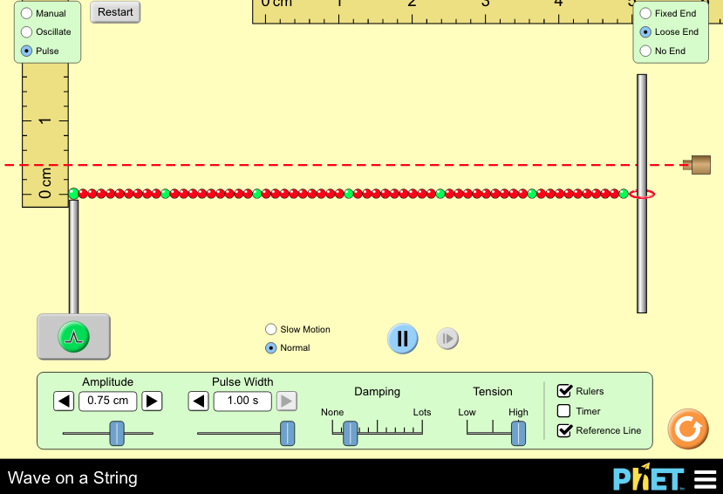

Procedure:
- Click and drag the vertical ruler to the left side and align the 0 cm with the resting point of the wave (like 0,0 on a graph).
  - (You don’t need the horizontal ruler yet, so just drag it out of the way).
  - Use the picture above for guidance.
- Send a pulse down the string and observe what happens. (click 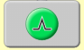, watch the wave, and observe the ring at the end 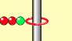.)
- Now click and drag the Reference line (laser) to line up at to 2nd mark of the ruler (this is 0.4 cm).
- Send another pulse and observe where the END of the wave (the ring) hits compared to the reference mark.
- Make adjustments to the amplitude until the END of the wave (the middle of the ring) hits exactly with the reference mark and write the value below. Make close and careful observations! ( 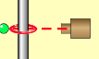 ← middle of ring)
- Move the Reference Line for the next Measured Height and repeat the process.
Measured Height at End of Wave  (where you set your Reference Laser) | Amplitude you used (cm)
0.4 cm | 0.65 cm
0.6 cm | 0.95 cm
0.8 cm | 1.25 cm

Use your data to answer this question:
What is the relationship between the amplitude of the wave and the amount of energy the wave is transmitting? Remember that energy is the ability to do “work” (to move something over a distance). In this case, the energy transmitting through the wave moves the ring at the end a certain distance.
The higher the amplitude I used, the __more__ energy the wave transmitted. I know this because: __the string went higher when I used a higher amplitude__.

Part 2:
Reset the simulation settings as follows:
Oscillate No end
Rulers Amplitude: 1.0 cm
Damping: none
Your screen should look like this:
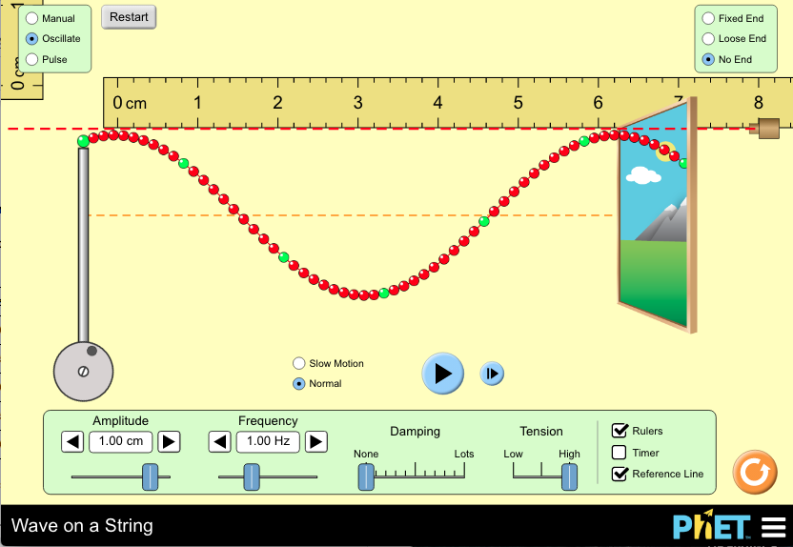
Procedure:
- Start with the frequency at 1.0 Hz. Your wave is probably moving already.
- Use the pause⏯ and frame advance⏭ buttons to stop your wave and adjust it so that you have at least 2 good crests (mountain tops).
  - I like to use the Reference Line (laser pointer) to see if they’re the same height.
- Use the horizontal ruler to measure from the top of one peak to the next - this is your wavelength.
- Record it in the table below, then repeat for the next frequency.
Frequency (Hz) | Wavelength (cm)
1.0 | 6.2 cm
1.5 | 4.1 cm
2.0 | 3.1 cm
2.5 | 2.5 cm
3.0 | 2.1 cm

Use your data (numbers!) to answer this question:
What is the relationship between the frequency of the wave and the wavelength?
The higher the frequency of the wave, the __shorter__ the wavelength. I know this because __the wavelength decreased when I increased the frequency__.

CONCLUSION:

In your own words, how would you describe these ideas from the lab?
Amplitude: | The difference between the average point of the wave and the highest point of the wave.
Frequency: | The number of waves over time.
Wavelength: | The distance between a top of one peak to the next.

〜 End of lab 〜

