Notes: Waves Basics Instructions Screencast
Directions: Watch the video to complete the notes with your teacher, then answer the practice questions.

A __wave__ is a __disturbance__ that carries __energy__ from one place to another.
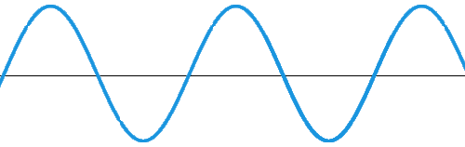

Resting position (or equilibrium)

KEY:
🙂(smiley face) __crest__: the __highest__ point in the wave
💜 __through__: the __lowest__ point in the wave
__amplitude__ : the distance or __height__ of the wave from __resting position__ position

__wavelength__ : the __distance__ between two __crests__

If you take high school physics in the future, you’ll learn all about this stuff ↓↓↓↓ I’m putting it here in case you’re interested. Stuff in yellow is what you need to learn for this year.
Term | Symbol | Definition | Equation | Units
Frequency | f | The number of crests (or complete cycles) that pass a certain point in a given amount of time, usually in one second | Number of Crests/Time  OR  Speed of Wave/Wavelength | Hertz (Hz)  One wave per second.
Wavelength | λ | The length from one crest to the next crest | Speed of Wave/Frequency | Meter (m)
Speed of Wave | v | The distance traveled by a wave in a given amount of time | Frequency X Wavelength | Meters/Second (m/s)

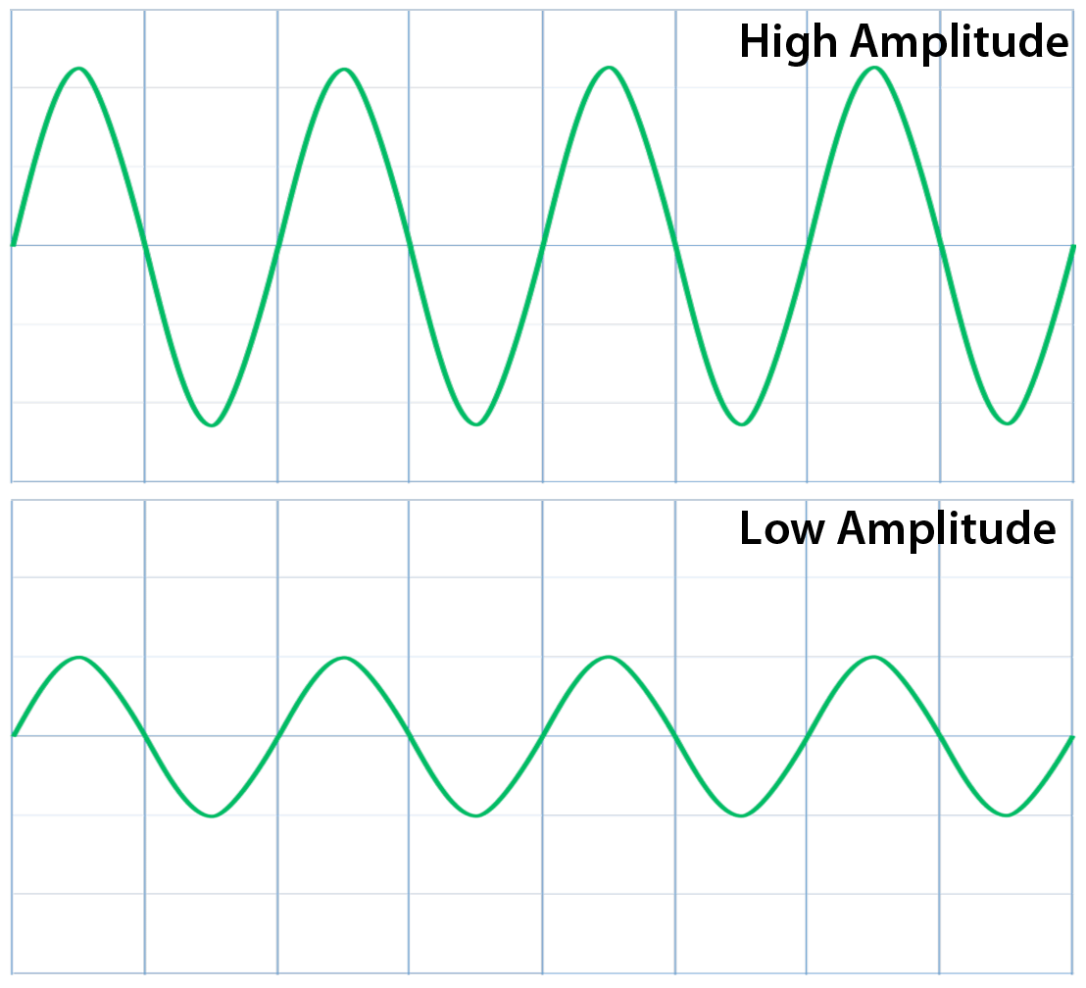
Energy in Waves

1. The amount of energy in waves is directly
__proportional__ to the __amplitude__.

__The higher__ the amplitude, the __higher__ the energy.
__The lower__ the amplitude, the __lower__ the energy.
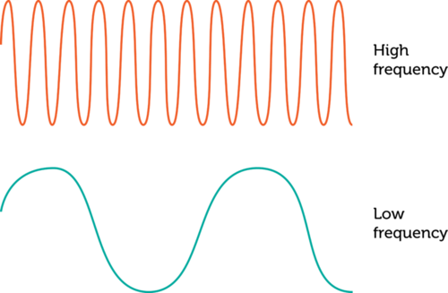
2. The amount of energy in waves is directly
__proportional__ to the __frequency__.

__The higher__ the frequency, the __higher__ the energy.
__The lower____ the frequency, the __lower__ the energy.

PRACTICE QUESTIONS!

Analyze the image below and answer the following questions.
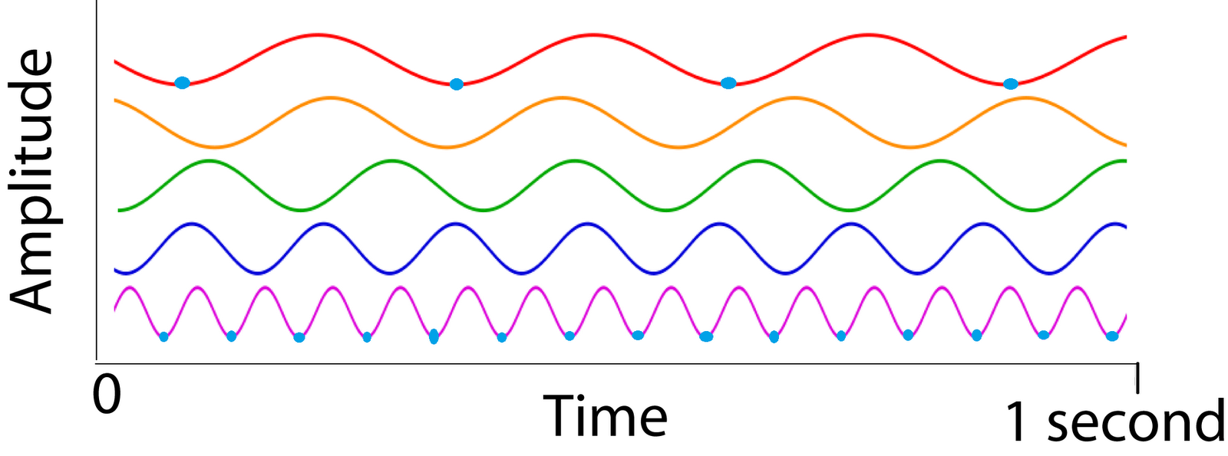
- Which wave has the longest wavelength? The shortest wavelength?
The red has the longest, the purple has the shortest.
- Describe what the wave with the longest wavelength looks like compared to the wave with the shortest wavelength.
It looks like it has less energy and it is slower.
- What is the frequency for each wave? (Simplest way: Count the crests, divide by the time)
  - Wave A: f = 3/1s = 3 Hz
  - Wave B: f = 4 Hz
  - Wave C: f = 5 Hz
  - Wave D: f = 7 Hz
  - Wave E: f = 14 Hz

- Which wave has the highest frequency? The lowest frequency?
Wave e has the highest, a has the lowest.
- Describe what the wave with the highest frequency looks like compared to the wave with the lowest frequency.
It looks like it has much more energy and it is faster.
- Which wave has the MOST energy? The LEAST energy? How do you know this?
Wave e has the most, a has the least. I know this because waves with higher frequency have a higher energy.

end!

