Day 3 Lesson
Waves Video Choice Activity
Instructions Screencast
Introduction: This week we’ve been focusing on mechanical waves - a wave that requires a medium (or some type of matter) through which to travel. Sound is a great example of a mechanical wave. It requires matter or particles in order to travel, which is why sound cannot travel in space, where there are no air particles. In this activity, you will choose 1 video to further explore sound OR learn about waves at a higher academic level. Read on for details...

Directions:
- For this activity you are going to choose ONE of the three options provided for you.
- When you have selected your option, you are going to click the link for that video, COPY and PASTE your worksheet (given in the link) onto this document, so it is easy for your teacher to see and grade after you have submitted it.
- Complete the activity.
- We strongly encourage students who are signed up for Honors Biology next year to complete one of the “Above Grade Level” options (in yellow).
- The options are as follows:

Options (CHOOSE 1) | Summary | Difficulty Level
Video 1 - The Science of Sound (Science Trek) | Learn more about sound waves and how they work. | At Grade Level - This video covers standards that match what is expected for 8th grade science.
Video 2 - Sound (Crash Course Physics) | Go in depth into the physics of sound waves and how they work | Above Grade Level - This video goes above and beyond the 8th grade level standards, moving into some high school physics information.
Video 3 - Traveling Waves (Crash Course Physics) | Learn more about waves in general, including exploring some formulas that can be used to describe different properties of waves. | Above Grade Level - This video goes above and beyond the 8th grade level standards, moving into some high school physics information.

Video 3 - Traveling Waves
(above grade level)

Watch this video and answer the questions on the worksheet with the detail provided in the video. Please use complete sentences where applicable.

- Using Google Draw, sketch a traveling wave, and insert the image below:

- What often happens when something in the physical world changes?
The information about the disturbance moves away from the source of the disturbance in each direction.

- What shape does the information make?
The shape of a wave.

- How do you calculate a wave's speed?
v = ƛ * f
wave’s speed = wavelength * frequency

- What does a wave's speed depend on?
On the medium.

- Identify the following waves by type.

Type of wave | Image
a. Pulse wave: when only 1 crest travels through the medium. | 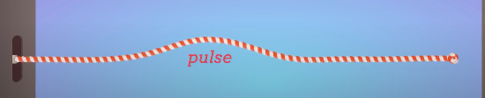
b. Continuous / sinusoidal wave: a wave with constant / repeating oscillations. | 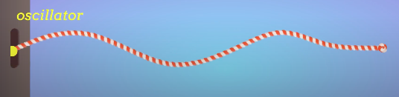
c. Transverse waves: the oscillation is perpendicular to the direction of the wave. | 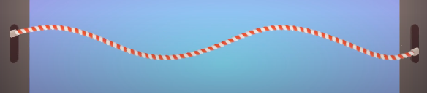
D. Longitudinal waves: the oscillations happen in the direction in which the wave is moving.

- All waves, no matter the type __transport__ __energy__.

- Write the formula for Total Energy below:
E = 1/2k * A²
total energy = half spring constant * amplitude squared

- What is a waves energy proportional to?
To the amplitude squared.

- Double amplitude = __4 *__ energy Triple amplitude = __9 *__ energy

- Write the formula for Intensity below:
I = P / A
Intensity = power / area

- Write the formula for Power below:
P = E / t
power = energy / time

- How does a spherical waves intensity decrease?
The wave spreads out over more surface area, so its intensity gets weaker, because they are distributed over more surface area. If we are 2 meters away from the source of the wave, the intensity of the source will be 4 times less than if we would be only 1 meter away from the source.
I ~ I/r²

- Explain the earthquake example (in complete sentences).
The waves get weaker as they spread out, because they are distributed over more surface area. In an earthquake, a spherical wave gets bigger and bigger as it travels, and the more it spreads out and gets distributed over more surface area, the weaker its intensity becomes.
A = 4𝞹 * r² (surface area = four pi * radius squared)
I ~ I/r² (as the wave travels away from the source, its intensity decreases by the square of the distance from the source)
If we are 2 meters away from the source of the wave, the intensity of the source will be 4 times less than if we would be only 1 meter away from the source. If we are 3 meters away, the intensity will be 9 times less. This is why if we are just a little farther away from the source of an earthquake, we will experience much less intensity than if we would be a little bit closer.

Waves end | Wave Reflected Back (highlight one)
Loose | Crest / Trough
Fixed | Crest / Trough

- Describe constructive interference:
2 crests with identical amplitudes go towards each other and when they overlap they combine to form a crest that is the sum of their original crests. In constructive interference, the waves build on each other.

- Describe destructive interference:
1 crest and 1 trough go toward each other and when they overlap they become flat. In destructive interference, the waves cancel each other out.

- Explain how noise cancelling headphones work:
They analyze the noise around them and generate a sound wave that destructively interferes with the sound wave around them. They cancel the sound waves around them out.

