Day 4 Lesson: Astronaut Question
Instruction Screencast
Intro: We’ve now learned about how sound works (last week) and how visible light works (this week). If you need more information or just want to review…
- Video
- Reading

Directions: Using your understanding from our Waves unit so far, respond to the question below using complete sentences.
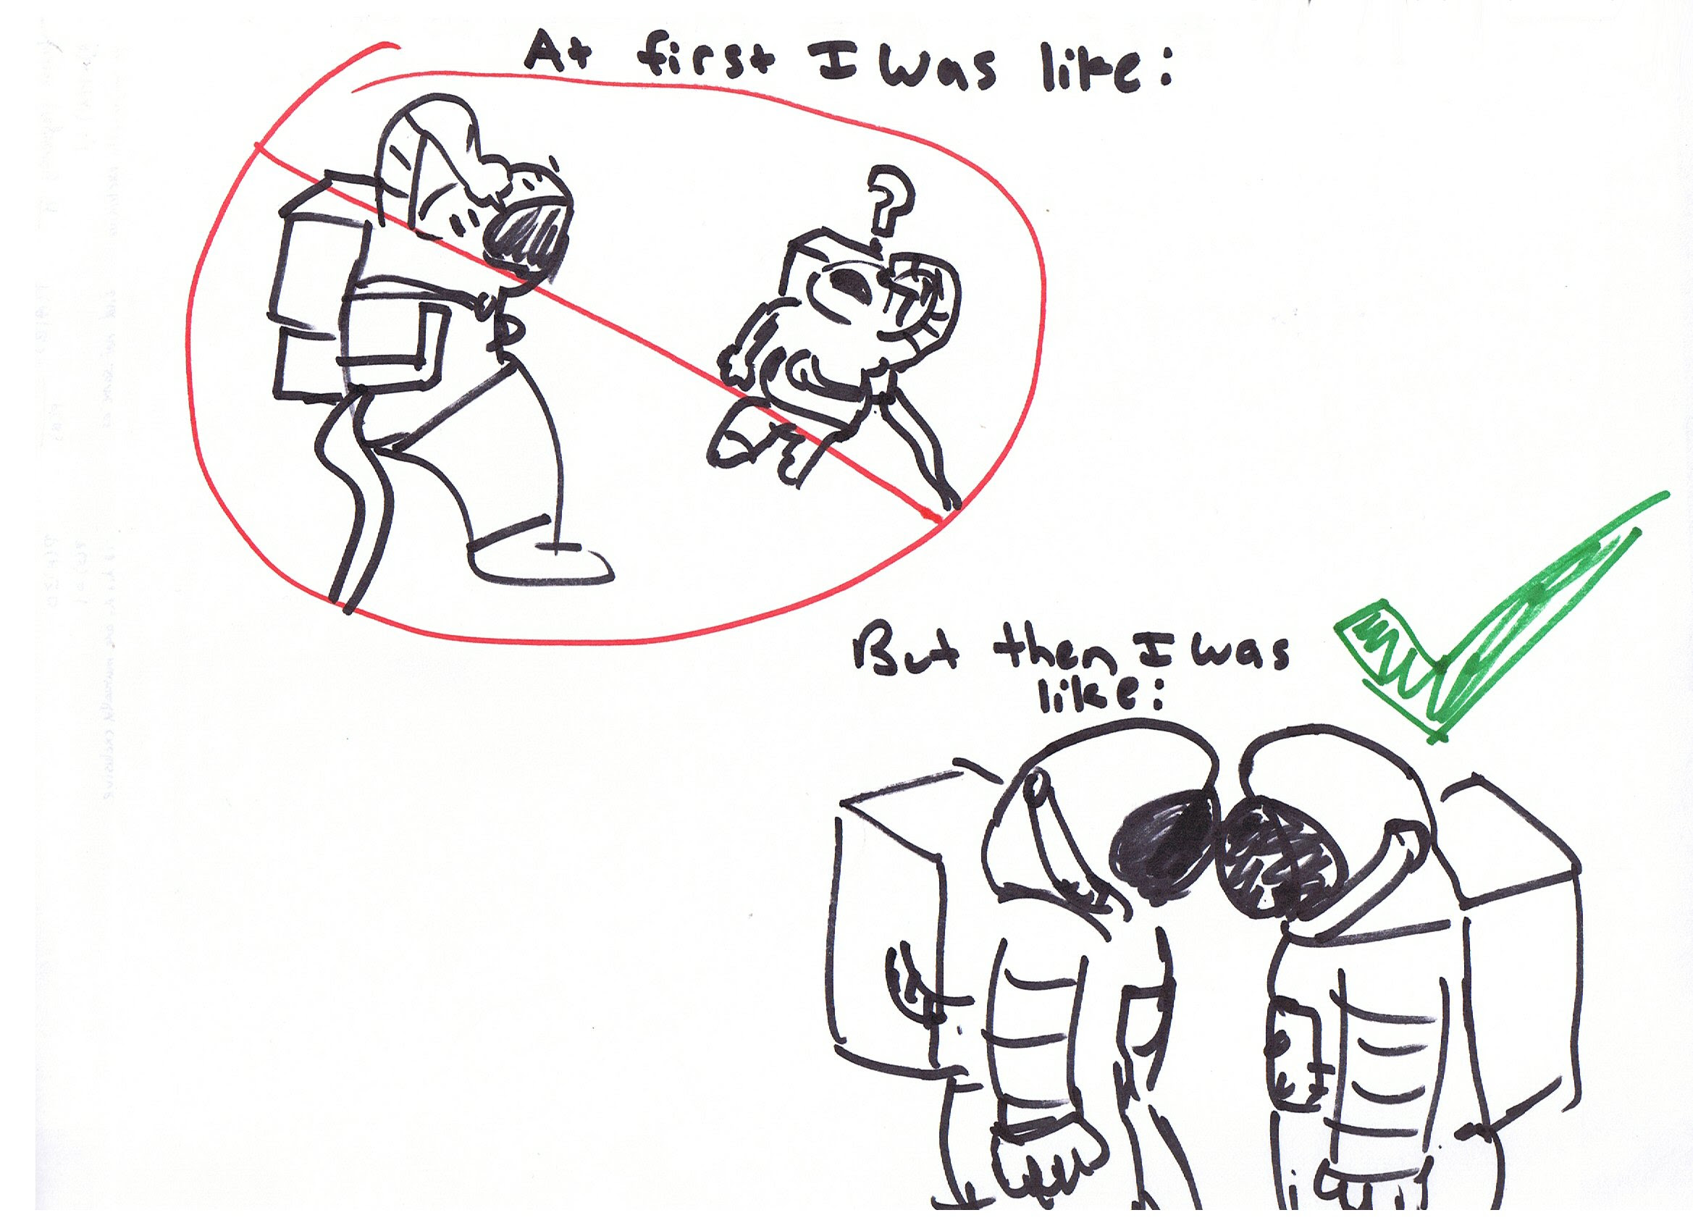
(Picture 1 shows two astronauts floating in space, confused because they cannot hear each other speaking. Picture 2 shows the two astronauts touching helmets with a green check mark, indicating that they can hear each other speaking.)

Question: How are these astronauts able to communicate with each other in space, according to the cartoon? Explain the science behind each picture.
You should use the terms:
Sound waves, mechanical wave, particles, travel, medium, vacuum, vibrate, Electromagnetic wave

My answer:
Sound waves are a type of mechanical wave. A mechanical wave is produced when a source of energy -- currently sound energy -- causes a medium to vibrate. During this vibration, sound energy is passed on from particles to particles until it reaches the ear. In space, there is no medium, only vacuum, so the energy has nothing to travel through. But when the astronauts touch their helmets, sound energy travels through their helmets and their bones -- this is called bone conduction -- so now they will be able to hear each other. Only electromagnetic waves are able to travel through vacuum because they do not need a medium.

